**Phase-4 Practice Project: Assisted Practice -**

**5.TWO WAY BINDING**

**SOURCE CODE:**

**app.component.html**

<h1>Component Interaction</h1>

<app-child></app-child>

**app.component.html**

<h1>Component Interaction</h1>

<h2>Parent Component</h2>

<!--Parent to child communication-->

<input type="text" (keyup)="0" #ptext>

<app-child [pdata]="ptext.value"></app-child>

**child.component.ts**

import { Component, OnInit } from '@angular/core';

@Component({

  selector: 'app-child',

  templateUrl: './child.component.html',

  styleUrls: ['./child.component.css'],

  inputs:['pdata']

})

export class ChildComponent implements OnInit {

  pdata:string="";

  constructor() { }

  ngOnInit(): void {

  }

}

**child.component.html**

<p>child works!</p>

<br>

<p>Value coming from Parent Component: <b>{{pdata}}</b></p>

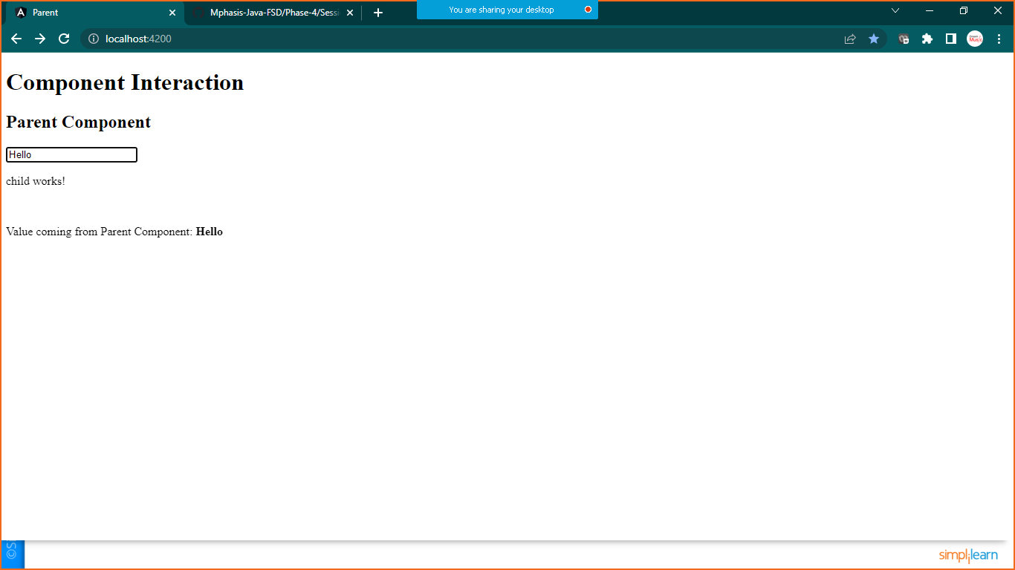

**CHILD TO PARENT COMMUNICATION**

**Child.component.html**

<p>child works!</p>

<br>

<p>Value coming from Parent Component: <b>{{pdata}}</b></p>

<hr>

<br>

<input type="text" #cdata (keyup)="onChange(cdata.value)">

**Child.component.ts**

import { Component, EventEmitter, OnInit } from '@angular/core';

@Component({

  selector: 'app-child',

  templateUrl: './child.component.html',

  styleUrls: ['./child.component.css'],

  inputs:['pdata'],

  outputs:['cevent'],

})

export class ChildComponent implements OnInit {

  pdata:string="";

  constructor() { }

  ngOnInit(): void {

  }

  cevent= new EventEmitter<String>();

  onChange(value:string){

      this.cevent.emit(value);

  }

}

**App.component.html**

<h1>Component Interaction</h1>

<h2>Parent Component</h2>

<!--Parent to child communication-->

<input type="text" (keyup)="0" #ptext>

<!--Child to  parent communication-->

<p>Value coming from child:<b>{{cdata}}</b></p>

<app-child [pdata]="ptext.value" (cevent)="cdata=$event"></app-child>

**app.component.ts**

import { Component } from '@angular/core';

@Component({

  selector: 'app-root',

  templateUrl: './app.component.html',

  styleUrls: ['./app.component.css']

})

export class AppComponent {

  title = 'parent';

  cdata:String="";

}

**OUTPUT:**

